**Confidence Intervals**

1. For each of the following statements, indicate whether it is True/False. If False, explain why.
2. The sample size of the survey should at least be a fixed percentage of the population size in order to produce representative results.
3. The sampling frame is a list of every item that appears in a survey sample, including those that did not respond to questions.
4. Larger surveys convey a more accurate impression of the population than smaller surveys.

I. True.

II. False.Only valid responses can be calculated as a part of the sampling frame.

III. True.

1. PC Magazine asked all of its readers to participate in a survey of their satisfaction with different brands of electronics. In the 2004 survey, which was included in an issue of the magazine that year, more than 9000 readers rated the products on a scale from 1 to 10. The magazine reported that the average rating assigned by 225 readers to a Kodak compact digital camera was 7.5. For this product, identify the following:
2. The population
3. The parameter of interest
4. The sampling frame
5. The sample size
6. The sampling design
7. Any potential sources of bias or other problems with the survey or sample
8. The population is the total number of readers. The population size is 9000.
9. The parameter of interest is the average rating given by the readers.
10. The sampling frame is the total population with size 9000.
11. The sample size is the number of readers who gave the average rating which is 225.
12. The sampling design is the probability of sample selection which is 225/9000 = 0.025.
13. Bias can occur in the sample if the brand that made the cameras is facing competition from other brands.
14. For each of the following statements, indicate whether it is True/False. If False, explain why.
15. If the 95% confidence interval for the average purchase of customers at a department store is $50 to $110, then $100 is a plausible value for the population mean at this level of confidence.

False as 100 cannot be a mean between 50 and 110.Mean should be around 80.

1. If the 95% confidence interval for the number of moviegoers who purchase concessions is 30% to 45%, this means that fewer than half of all moviegoers purchase concessions.

Confidence Interval = 30% to 45%

Mean number of moviegoers = 37.5%

True as the number is much lesser than 50%

1. The 95% Confidence-Interval for *μ* only applies if the sample data are nearly normally distributed.

True as the sample data needs to be distributed normally so as to calculate the

confidence interval.

1. What are the chances that 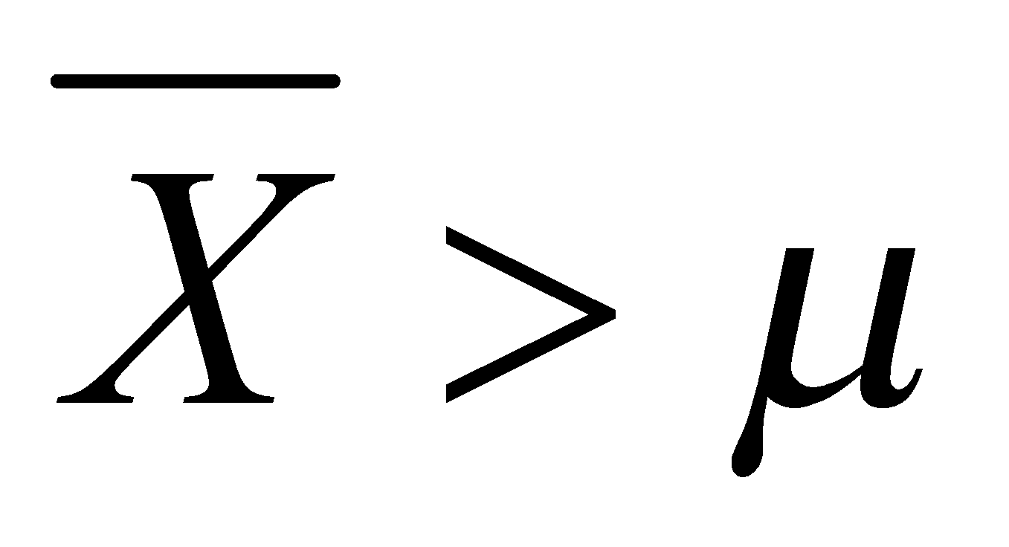?
2. ¼
3. ½
4. ¾
5. 1

Sample mean is an unbiased mean of the sample of the total population.So it cannot

be much greater or smaller than the population mean.The probability is ½.

1. In January 2005, a company that monitors Internet traffic (WebSideStory) reported that its sampling revealed that the Mozilla Firefox browser launched in 2004 had grabbed a 4.6% share of the market.
2. If the sample were based on 2,000 users, could Microsoft conclude that Mozilla has a less than 5% share of the market?

The sample was based on 2000 users so it was lesser than the total population so

Mozilla had lesser than 5% of the total share of the market as sample size was

only 4.6%.

1. WebSideStory claims that its sample includes all the daily Internet users. If that’s the case, then can Microsoft conclude that Mozilla has a less than 5% share of the market?

If the sample is based on all the daily Internet users then Mozilla could have more

than 5% share of the market as the sample size is larger than population of 2000

users.

1. A book publisher monitors the size of shipments of its textbooks to university bookstores. For a sample of texts used at various schools, the 95% confidence interval for the size of the shipment was 250 ± 45 books. Which, if any, of the following interpretations of this interval are correct?
2. All shipments are between 205 and 295 books.

False as the level of confidence is only 95%.

1. 95% of shipments are between 205 and 295 books.

True as the level of confidence is 95%.

1. The procedure that produced this interval generates ranges that hold the population mean for 95% of samples.

True as the level of confidence indicates the percentage of the samples that follow

the confidence interval.

1. If we get another sample, then we can be 95% sure that the mean of this second sample is between 205 and 295.

False as different samples have different confidence intervals and levels of

confidence.

1. We can be 95% confident that the range 160 to 340 holds the population mean.

True as the population mean is exactly 250 and fits the interval.

1. Which is shorter: a 95% *z*-interval or a 95% *t*-interval for *μ* if we know that σ =s?
2. The z-interval is shorter
3. The t-interval is shorter
4. Both are equal
5. We cannot say

The t interval is shorter as the interval is based on the sample whereas the z interval is

based in the whole population.

Questions 8 and 9 are based on the following: To prepare a report on the economy, analysts need to estimate the percentage of businesses that plan to hire additional employees in the next 60 days.

1. How many randomly selected employers (minimum number) must we contact in order to guarantee a margin of error of no more than 4% (at 95% confidence)?
2. 600
3. 400
4. 550
5. 1000

Confidence Level = 95%

Z score = 1.96

Margin of error = 4%

Population number = n

Margin of Error = z*s/sqrt(n)

0.04 = 1.96*0.4/sqrt(n)

n = 400

1. Suppose we want the above margin of error to be based on a 98% confidence level. What sample size (minimum) must we now use?
2. 1000
3. 757
4. 848
5. 543

Confidence Level = 98%

Z score = 2.326

Margin of error = 4%

Population number = n

Margin of Error = z*s/sqrt(n)

0.04 = 2.326*0.4/sqrt(n)

n = 543